So far, we have had a good variety of wild flowers appear. Species such as Oxeye Daisy, Lady’s Bedstraw, Yarrow, Poppy, Vipers Bugloss, Mallow, Knapweed and Scabious, have all flourished.  In late summer, after the seed has dropped, we will cut and collect the meadow areas to help manage, maintain and improve them for the future.  We are fortunate to have the support of our wonderful Rector, who shares our passion for wildlife and provides many valuable services to our community. We hope to continue to work in unison, to further improve the churchyard for the benefit of the wildlife and the people who visit it.  We have discussed the possibility of installing Swift boxes on the church tower, an exciting and worthwhile project for the future.  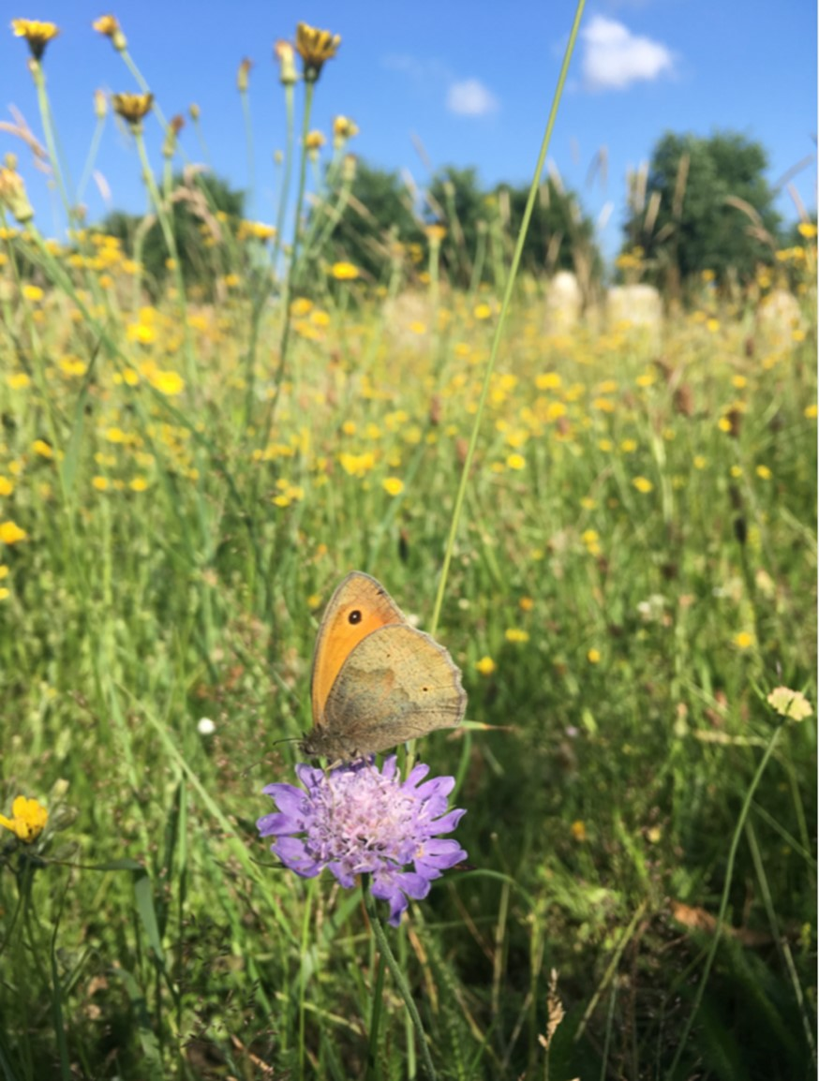
  Brandon Town Council
  Old School House
  Market Hill
  Brandon
  Suffolk
  IP27 0AA
  01842 811844 
  office@brandontc.co.uk
  [Company Name]
  Contact us:Old School HouseMarket HillBrandonSuffolkIP27 0AA
  Brandon Cemetery
  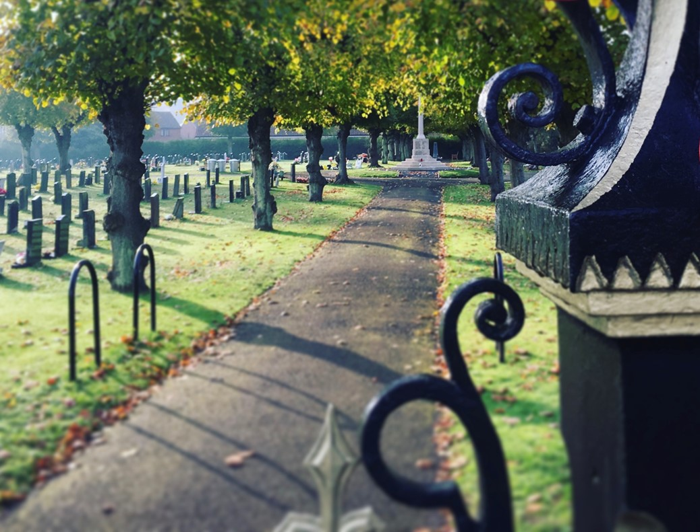

 |  |  | Doing our bit for Nature  We are very conscious of wildlife within the cemetery and during the winter of 2018/19 installed several bird boxes for House Sparrows, Blue tit and Great tit. Birds are often considered important to people who are grieving, so we have also installed a bird bath and feeding station, giving people the opportunity to sit and watch the birds, while taking time to reflect.  The mixed species hedge that surrounds the southern boundary provides an excellent habitat for birds and mammals. It is cut just once a year, usually at the beginning of September. This is to protect the birds, that nest from March to the end of August.  It is hard to balance the need for aesthetics within the Cemetery with the need for habitat diversity for our wildlife. So we found a balance by changing the way we manage the beautiful churchyard of St Peter’s. We have increased the amount of grass we leave uncut, to allow the vegetation to complete its natural life cycle, produce and drop seed.  Meadows also help reduce our carbon footprint, absorbing carbon from the atmosphere and storing it in the ground. Also, reducing the amount of times the area is cut with petrol machinery, has huge environmental and financial benefits for the town. We have cut paths through these areas, to encourage you to wander through the meadow and get close to nature!  We have noticed a considerable increase in biodiversity since encouraging these areas to go wild and hope to undertake some survey work to start establishing a species list which would better enable us to manage these areas with wildlife in mind. If you would like to volunteer to help with wildlife surveys, please don’t hesitate to get in touch!  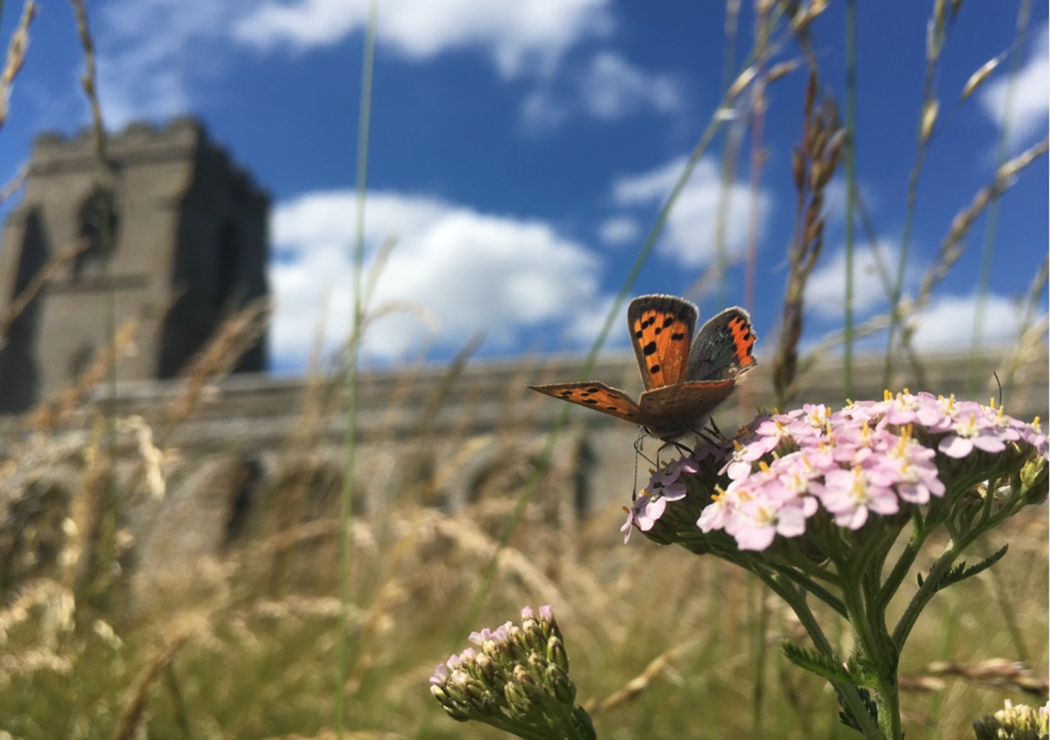
 |  |  | 5

The War memorial  The Brandon War Memorial was constructed after a committee was set up to raise funds, in January 1919. By the summer of the same year, £240 had been raised. The memorial was built and officially unveiled by Lt-Col R E Spragge on 17th October 1920, in front of several hundred people.  At the conclusion of the ceremony numerous floral tributes were laid on the steps of the memorial. The ringers rang muffled peals on the bells of St Peter’s Church before the ceremony. Afterwards, the bells rang out across Brandon. The flag was at half mast and later hoisted to the top of the staff in commemoration.  The memorial is 14 ft high, and an elegant octagonal cross resting on four tiers. Carved on the front, in the centre of the cross, is a Crusader’s sword. Inscribed on the four square panels, are the names of all the men who gave their lives during WW1, WW2 and the Korean War.  The memorial stands on the central mound of the Cemetery, opposite the main entrance, and is much admired.  It has been Grade II listed since the 2nd February 2018.  In 2017, Brandon Cemetery also became home to a Polish memorial. This commemorates the Polish servicemen who fought alongside the British during WWII, and their families who came and settled in Brandon. It recognises their suffering during and after, those troubled times. |  |  | A Brief History  Brandon Cemetery comprises of 3.65 acres of burial ground, with avenues of Lime pollards, which add grace and beauty to the site.  Our earliest historical records show that Robert and Francis Diggon purchased a field to the East of St Peter’s churchyard from the owner of Brandon Hall, Joseph Randyll Burch, in 1805. It measured approximately 4.5 acres. During the process of enclosure, further land was also allotted to the south of this field and total area now extended from Church Road to London Road.  Their partnership was dissolved in 1821 and Francis Diggon retained the land until Southern extension: The first extension was to the south into what had been Diggon’s land. It is unclear from the Diggon sale deeds of 1846 whether the graveyard had been extended by then. However, the 25inch ordinance Survey map clearly shows that it had been extended by 1880. The Land Tax Valuation survey of the parish shows that this enlarged graveyard was owned by the Churchwardens.  At a later date, sometime between 1880 and 1903, a new burial ground was laid out on the remaining land bought by the Diggon’s from Burch in 1805. The Land Tax Valuation shows this as belonging to the Brandon Parish Council.  The area we see today was formally used as allotments, prior to the very first burial, in the early 1900’s.
4 |  |  | 1

The Cemetery today  Brandon Cemetery is managed by Brandon Town Council, who employ a small team of operatives (known as Brandon Town Keepers) to maintain the site and various other areas around town. Our dedicated staff take great pride in their work and undertake a wide range of maintenance tasks. They are responsible for cutting the grass, strimming, weeding, hedge cutting, waste management, lifting and removing the epicormic growth from the Lime trees, (BTC has approximately 340 Lime trees in the Cemetery, Churchyard and Victoria Avenue), path edging, maintenance of the Town flower beds, habitat management, path repairs and any other task required, which could be anything from painting gates, to putting up the Town Christmas tree!  The Cemetery is still used for burials and cremation interments today, although space is now becoming a premium. In 2019, Brandon Town Council finally purchase a new area of land, to the West of St Peters Church, ensuring our residents have somewhere to be buried in Brandon, for the foreseeable future.  There are plenty of places to sit and rest within the Cemetery. We have installed and refurbished several benches in recent years, giving ample opportunity to sit and enjoy the tranquil surroundings.  There is a central water point, by the War Memorial and watering cans are provided for your use. Please ensure they are returned to the water point after use, If you require information on a grave number or its location, please don’t hesitate to contact the Town Council Office and someone will be able to assist you. |  |  | Often during windy weather, silk flowers and ornaments get blown from the graves. As I am sure you understand, the Town Keepers cannot return items to graves as they will not know where they have come from. Please do not return windblown items to graves unless you are 100% sure where the item has come from! It can cause deep distress if an item is placed on the wrong grave. Wind swept items will be collected by the Town Keepers in due course and placed in the Lost Property Section of the Cemetery, in the Northwest corner, by the council yard. Recovered items, if unclaimed, will be stored there for 6 months before being disposed of.  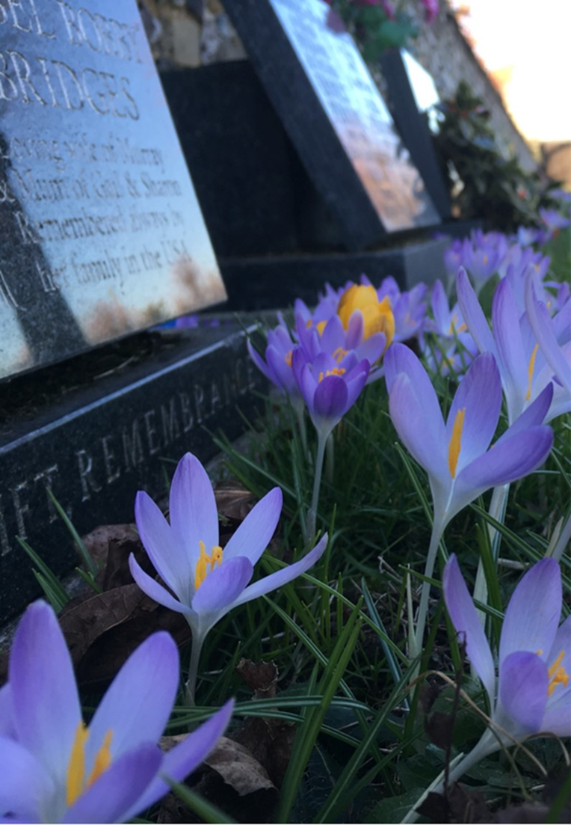
2

